**Task 2:**

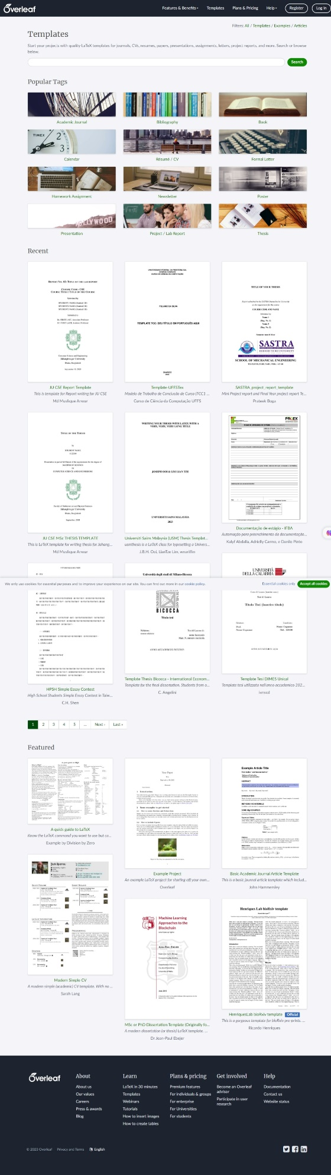

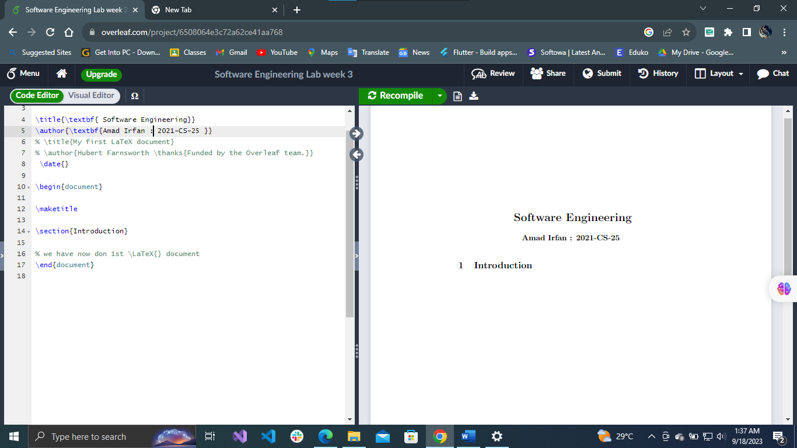**Task 3 :**

**Task 5 :**

**Task 6 :**

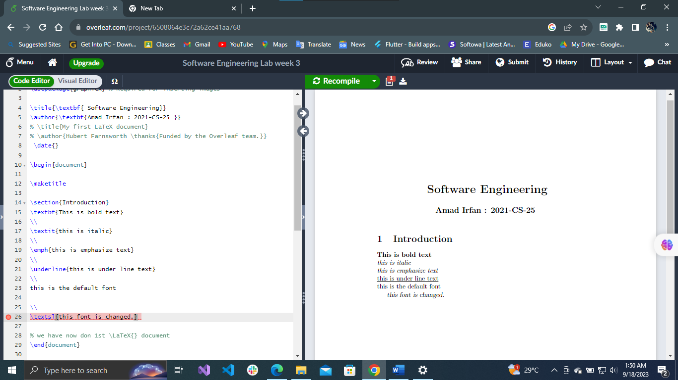

Task 7 :

Task 8 :

Task 9 :

Task 10 :

Task 11:

Task 12 :

Task 13 :

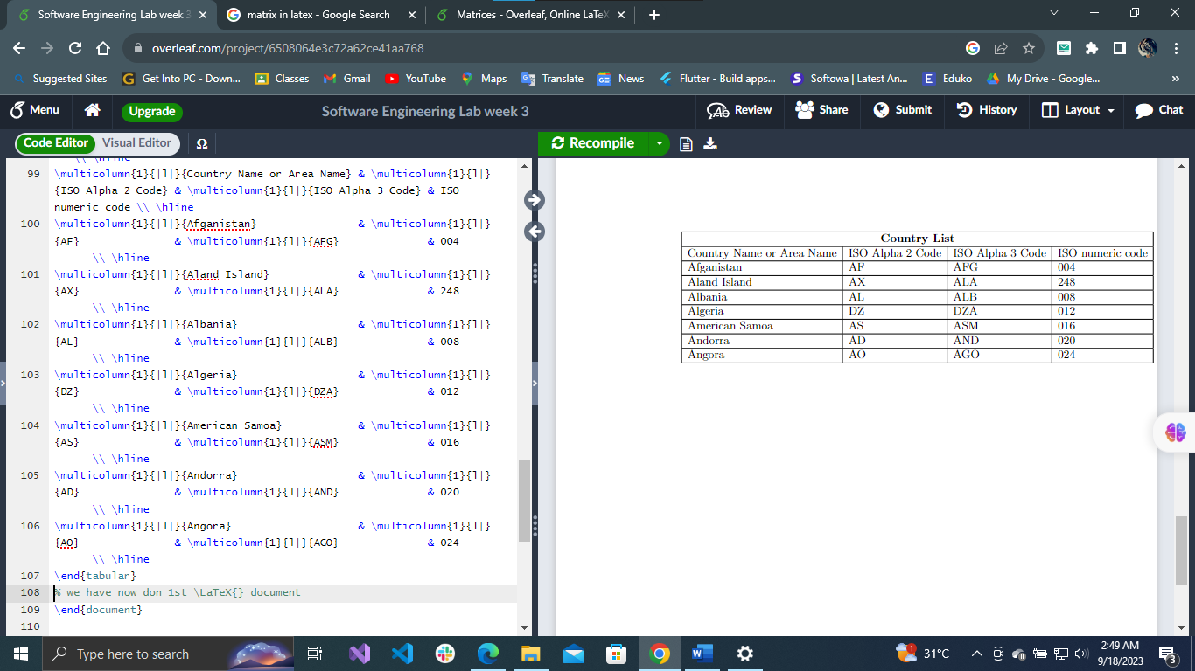

Task 14 & 15:

